**Application note: The soldering station**

|  |  |
| --- | --- |
| Author | Quinten Mathijs |

Content

1. Inhoudsopgave

1 Inhoudsopgave 1

1 Introduction 1

2 Material and methods 2

3 Results 6

3.1 Description 6

3.2 Testing 9

4 Discussion 10

5 Reference list 10

# Introduction

A soldering station is an essential tool for any electronic hobbyist or professional, as it provides a controlled temperature environment for soldering components onto a programmable circuit board (PCB). By using a good soldering station, the quality of solder joints can be significantly improved, resulting in stronger and more reliable connections. In order to create our DIY soldering station, we relied on the Elektor magazine, a well-known international publication that offers valuable electronic engineering information and innovative solutions. Elektor featured an article on a DIY soldering station, which served as a guide for successfully completing our project. This application note aims to discuss the materials and methods employed in the creation of the soldering station, as well as the details of the finished project.

# Material and methods

The first step in creating a soldering station involves designing the circuit. For this project, we used a schematic design from Elektor magazine as starting point. The circuits were the modified to meet our specific requirements. Once the modifications were complete, we proceeded to create a custom PCB using Altuim Designer. To ensure accurate schematic designs, a library of components was utilized. The completed schematics were thoroughly checked by the lecturer before moving on to the custom PCB design phase. During this stage, the footprints of the components played a crucial role. Footprints consist of pads or through-holes that facilitate the attachment and connection of components to the PCB. The footprint on the circuit board aligns with the component’s lead placement. Choosing the correct footprint is vital for subsequent stages of the project, especially during PCB assembly. Once the footprints were correctly placed according to Elektor’s schematics, the final PCB design was ready. Finally, the PCB was sent to a PCB prototyping service responsible for its manufacturing.

The PCB prototyping service used is in this project was JLC PCB. JLC PCB is a well-known and reputable company that specializes in manufacturing printed circuit boards based on custom designs. When the PCB design was completed and ready for manufacturing, it was sent to JLC through their online platform. The process typically involves uploading the design files, the gerber files. These specify the desired specification such as the number of layers, board dimensions, and other technical requirements. JLC then reviews the design files and prepares them for production. They use advanced manufacturing techniques and machinery to fabricate the PCBs according to the specifications provided. This includes processes like printing the circuit pattern, etching chopper layers, drilling holes, and applying solder mask and silkscreen layers.

In the meantime, a project was initiated using Fusion 360. Fusion 360 served as the software for creating a case for the soldering station. During the “Project ontwerpen” lessons, Fusion was introduced and explained. Throughout the process of designing the case, several factors had to be taken into consideration. These included the dimensions of the PCB, the necessary openings for the display, temperature sensor, power supply, and soldering iron. To commence the case design, a sketch of the soldering station’s outer dimensions, incorporating the required openings, was created. The modelling tools in Fusion were utilized to generate a detailed 3D model of the case. Once the 3D model was finalized, it was exported in STL file format to facilitate manufacturing using a 3D printer. The STL file served as the input for the 3D printer, enabling the production of the actual case.

To source the components, we once again relied on Elektor’s article, which provided a comprehensive list of all the necessary components for constructing the soldering station. A group of students in the class took the initiative to organize a joint purchase for the majority of the components. While participation in the group buy was not mandatory, it proved to be beneficial as it saved us considerable time and effort in searching for individual components. To facilitate this process, an Excel file containing the components to be ordered was shared among the group.

|  |  |  |
| --- | --- | --- |
|  | MFR No. | Package |
| Resistors |  |  |
| 18 Kohm | <https://www.lcsc.com/product-detail/Chip-Resistor-Surface-Mount_VO-SCR0805J18K_C3017916.html> | 805 |
| 1 Mohm | <https://www.lcsc.com/product-detail/Chip-Resistor-Surface-Mount_FOJAN-FRC0805J105-TS_C2907302.html> | 805 |
| 68 Kohm | SCR0805J68K | 805 |
| 5,6 Kohm | SCR0805J5K6 | 805 |
| 10 Kohm | <https://www.lcsc.com/product-detail/Chip-Resistor-Surface-Mount_UNI-ROYAL-Uniroyal-Elec-0805W8F1002T5E_C17414.html> | 805 |
| 100 ohm | <https://www.lcsc.com/product-detail/Chip-Resistor-Surface-Mount_UNI-ROYAL-Uniroyal-Elec-0805W8F1000T5E_C17408.html> | 805 |
| 10 Mohm | <https://www.lcsc.com/product-detail/Chip-Resistor-Surface-Mount_FOJAN-FRC0805J106TS_C2930232.html> | 805 |
| 4,7 Kohm | <https://www.lcsc.com/product-detail/Chip-Resistor-Surface-Mount_FOJAN-FRC0805J472-TS_C2907326.html> | 805 |
| Inductor |  |  |
| L1 | <https://www.lcsc.com/product-detail/Power-Inductors_KOHERelec-PMI201214S-100M_C2922559.html> | 805 |
| L2 | [**https://www.mouser.be/ProductDetail/875-CM**](https://www.mouser.be/ProductDetail/875-CM2545X171R-10) | 2545 |
| Capacitor |  |  |
| 4700 uF | <https://www.lcsc.com/product-detail/Aluminum-Electrolytic-Capacitors-Leaded_CX-Dongguan-Chengxing-Elec-GR478M050O25RR0VZ2FPD_C45663.html> | D25xL25mm plugin |
| 10 uF | <https://www.lcsc.com/product-detail/Aluminum-Electrolytic-Capacitors-SMD_ST-Semtech-CS1E100M-CRC54_C98750.html> | D4XL5,4 |
| 100 nF |  | 805 |
| 100 uF | <https://www.lcsc.com/product-detail/Aluminum-Electrolytic-Capacitors-SMD_Nichicon-UWT1H101MNL1GS_C445063.html> | SMD,D8xL10mm |
| 10 nF | <https://www.lcsc.com/product-detail/Multilayer-Ceramic-Capacitors-MLCC-SMD-SMT_CCTC-TCC0805X7R103M500DT_C376921.html> | 805 |
| Semiconductors |  |  |
| 1n4007 | A7 | SOD-123Fl |
| Zener | <https://www.lcsc.com/product-detail/Zener-Diodes_Shandong-Jingdao-Microelectronics-BZT52C5V1_C353516.html> | SOD-123Fl |
| 1n14148 | <https://www.lcsc.com/product-detail/Switching-Diode_Shandong-Jingdao-Microelectronics-1N4148W_C115103.html> | SOD-123Fl |
| Brug | <https://www.lcsc.com/product-detail/Bridge-Rectifiers_MDD-Microdiode-Electronics-TTR8MF_C712546.html> | TTF |
| BC847C | <https://www.lcsc.com/product-detail/Bipolar-Transistors-BJT_SALLTECH-BC847C_C3027113.html> | SOT-23 |
| MOSFET-P | <https://www.lcsc.com/product-detail/MOSFETs_UTC-Unisonic-Tech-UTT18P10L-TN3-R_C84900.html> | TO-252-2(DPAK) |
| BC857C | <https://www.lcsc.com/product-detail/Bipolar-Transistors-BJT_Jiangsu-Changjing-Electronics-Technology-Co-Ltd-BC857_C2139.html> | SOT-23 |
| DC/DC | <https://www.mouser.be/ProductDetail/580-OKI78SR5-1.5W36C> | ? |
| MCP6002-E/MS | <https://www.mouser.be/ProductDetail/Microchip-Technology-Atmel/MCP6002-E-MS?qs=huzeVNXgovXv0kPjGdVLUA%3D%3D> | MSOP-8 |
| Mircocontroler | <https://www.mouser.be/ProductDetail/556-ATMEGA4809-AU> | TQFP-48 |
| relay | <https://www.mouser.be/ProductDetail/TE-Connectivity-PB/RT424005F?qs=8wHch9UpSvaH%252B%252BmsSCbj0Q%3D%3D> | ? |
| IC2 7seg | <https://www.lcsc.com/product-detail/LED-Display-Drivers_TM-Shenzhen-Titan-Micro-Elec-TM1637-TA2007_C5337160.html> | SOP-20 |
| encoder | <https://www.lcsc.com/product-detail/Rotary-Encoders_BOURNS-PEC11R-4220F-S0012_C143817.html> | ? |

The group buy amounted to approximately 40 euros per student, covering a significant portion of the required components. However, there were still some components that each of us needed to purchase individually. To fulfil this requirement, the local electronics shop called Gotron was contacted for procuring the remaining components. The remaining components amounted to approximately 130 euros, resulting in a total cost of 170 euros. Among the purchases, the soldering iron from Wëller represented the highest expense, amounting to a total of 60 euros.

# Results

## Description

In this project, we tried to design and construct a soldering station, combining electronic and mechanical components to create a functional and efficient device. This description will provide an overview of the different aspects of our soldering station, including its functionality, electrical schematic, PCB design, mechanical design, and the final product.

Our soldering station provides a controlled temperature environment for soldering electronic components onto a PCB. It features a temperature control system that allows the user to set and maintain the desired soldering temperature. The station also includes a display panel for monitoring the temperature. Additionally, safety features as thermal protection and grounding ensure safe operation.

The electrical schematic serves as the blueprint for the soldering station’s electronic circuitry. It outlines the connections between various components, including the temperature sensor, power supply, control unit and display module. The schematic provides a clear understanding of the electrical layout and enables efficient assembly and troubleshooting.

* Control unit

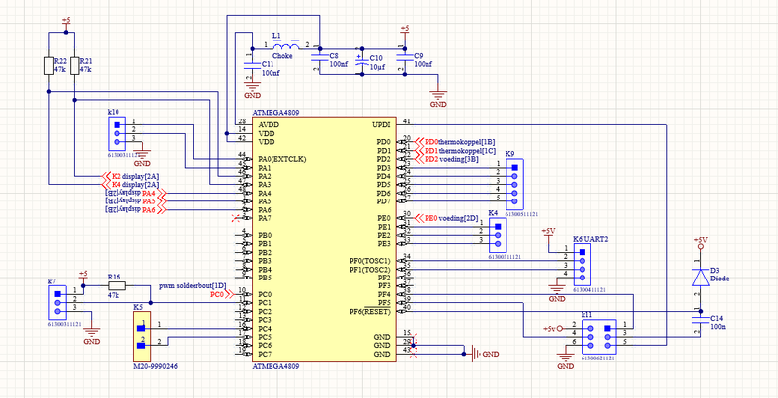

* PWM

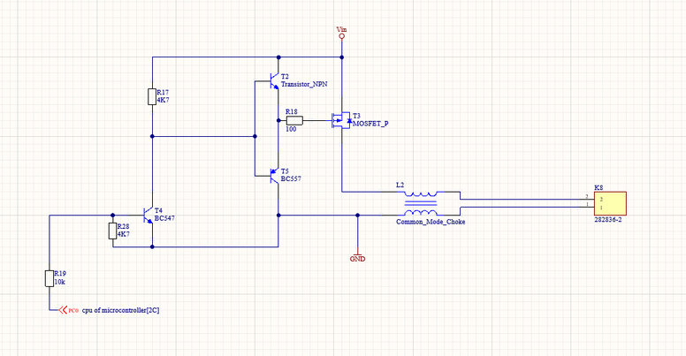

* Temperature sensor

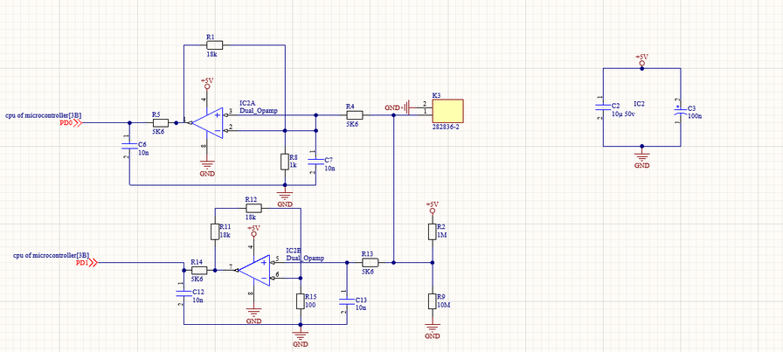

* Display module

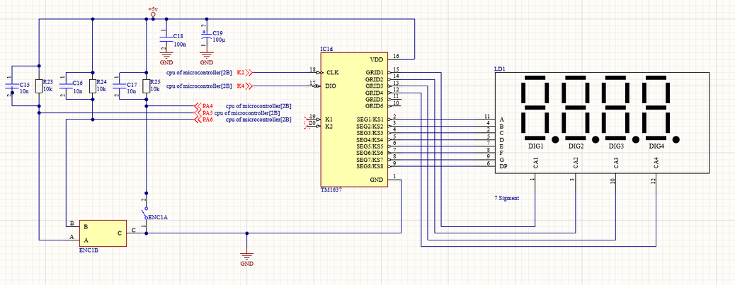

* Power supply

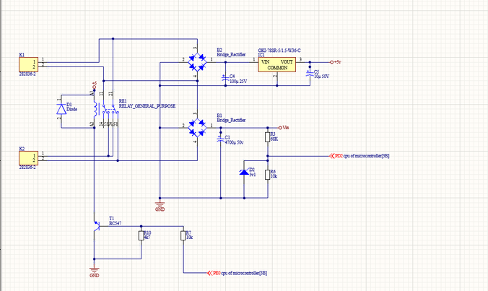

The PCB design translates the electrical schematic into a physical circuit board layout. It incorporates the necessary copper traces, pads, and through-holes to establish proper connections between the components. The PCB design takes into account the size and placement of the components, ensuring efficient signal flow and optimal functionality. However, due to a mistake in the MOSFET footprint, the PCB design needs to be revised. The incorrect connection of the MOSFET must be desoldered and reconnected correctly to rectify the issue with the transistor circuit. By rectifying this mistake, we aim to restore the functionality and performance of the soldering station. While the initial soldering station project encountered an issue with the MOSFET footprint, leading to excessive heat in the transistor circuit.

The mechanical design encompasses the physical structure and enclosure of the soldering station. It provides a protective housing for the internal components, offering stability and user-friendly ergonomics. The finalized mechanical design includes openings for the display, rotary encoder, and power supply, facilitating ease of use and accessibility.

° stand for soldering iron

## Testing

To ensure the proper functioning of the PCB, we conducted a series of tests. First, we performed a thorough visual inspection, examining the board for any visible defects such as solder bridges, missing or misaligned components, damaged traces, or poor solder joints. It was crucial to pay close attention to physical damage or anomalies that could potentially affect the circuit's performance.

Next, we proceeded to connect the power supply to the PCB and meticulously verified that the components received the appropriate voltage levels. Using a multimeter, we measured the voltages at different points on the PCB and compared them to the expected values indicated in the design or datasheets.

To ensure the integrity of the circuit, we performed a continuity test. This involved using a multimeter to check for proper establishment of all traces and connections on the PCB, ensuring there were no open or shorted circuits. We particularly focused on critical paths, including power and ground traces, signal paths, and key interconnections.

For functional validation, we conducted tests tailored to the specific circuit and its intended functionality. This entailed supplying input signals, observing output responses, and testing various features and functionalities. To monitor and analyze signals at different points on the PCB, we utilized tools such as oscilloscopes, logic analyzers, and other suitable test equipment.

Additionally, we conducted component-specific tests to ensure the proper functioning of individual components such as ICs or sensors. Following the component datasheets, we performed tests such as input/output verification, sensor calibration, or communication protocol testing. It was essential to confirm that all components were operating within their specified parameters.

To evaluate the PCB's robustness and performance under different conditions, we exposed it to varying environmental factors, including temperature and humidity variations. This test aimed to identify any potential issues related to thermal management, moisture sensitivity, or environmental interference that could affect the PCB's performance.

In instances where it was feasible, we assembled a prototype system incorporating the PCB and other relevant components. Through comprehensive testing of the entire system, we assessed its overall performance, functionality, and reliability. This testing phase often involved subjecting the system to real-world scenarios or simulating relevant operating conditions.

By conducting these thorough tests, we ensured that the PCB was thoroughly evaluated and met the intended design specifications and requirements. This diligent testing process increased the likelihood of a successful and reliable final product.

# Discussion

During the design process, I encountered difficulties primarily with two aspects: using Fusion 360 for the first time and the issue with the MOSFET. Working with Fusion 360 presented a learning curve as it was my first experience with the software. I struggled initially to grasp the tools and start designing the case for the soldering station. To overcome this challenge, I sought assistance from tutorials, online resources, and peers who were more experienced with Fusion 360. With their guidance, I gradually became more proficient and was able to create the desired 3D model for the case.

The issue with the MOSFET was another hurdle in the project. Due to a mistake with the footprint, the transistor circuit was getting excessively hot. Recognizing this problem, I realized that I needed to desolder the MOSFET and reconnect it correctly. To resolve this issue, I carefully desoldered the MOSFET from the PCB, making sure not to damage any other components. I then obtained the correct footprint information and reconnected the MOSFET in the right orientation. This rectified the overheating issue and restored the functionality of the circuit.

Reflecting on the overall process, I would say that things did not go exactly as expected. While the challenges with Fusion 360 and the MOSFET caused delays and required additional effort, they also provided valuable learning experiences. Through these difficulties, I gained a deeper understanding of the design process and troubleshooting techniques. In hindsight, I would approach the project differently by seeking more guidance and training on Fusion 360 before starting the design phase. This would have helped streamline the process and mitigate some of the initial struggles.

Currently, the project is functioning well after resolving the MOSFET issue. However, there may still be some minor issues that need to be addressed. It is important to thoroughly test and evaluate the soldering station's performance and reliability in real-world scenarios. This testing phase may uncover any remaining issues or areas for improvement. Continuous monitoring and feedback from users can help identify and address any unforeseen problems that may arise.

Overall, despite the encountered difficulties, the project provided valuable insights and hands-on experience in PCB design and troubleshooting. It taught me the importance of meticulousness and attention to detail in the design and testing phases. The challenges faced along the way have contributed to my growth as a designer and problem solver.

# Reference list

* Elektor magazine 2105